# **Creating Stream Analytics Job to Analyse Phone Calls**

# This demo shows how to use Azure Stream Analytics to analyse a sample phone call that is generated by a client application. The phone call data generated by the client application contains some fraudulent calls and we will define a Stream Analytics job to filter such calls.

Before beginning this demo, make sure to download an application from this link for generating phone call event.

<http://download.microsoft.com/download/8/B/D/8BD50991-8D54-4F59-AB83-3354B69C8A7E/TelcoGenerator.zip>

**Creating Event Hub:**

This demo is about creating event hub service in azure portal. To create the service, go to **+** **Create a resource -> Internet of Things -> Event Hubs**. Then give it a name, choose a required pricing tier, a resource group and click on create.

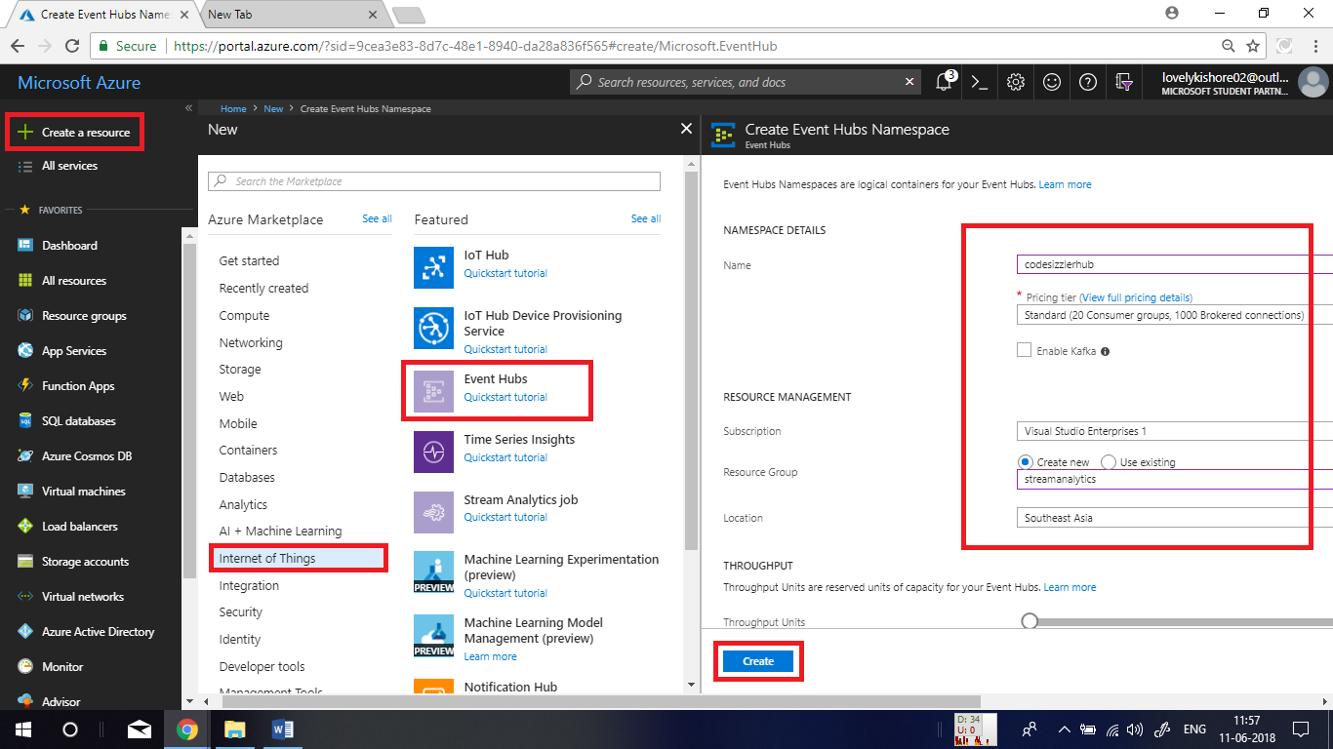

Once the event hub gets created, in its overview page, click on **+ Event Hub** to create event hub.

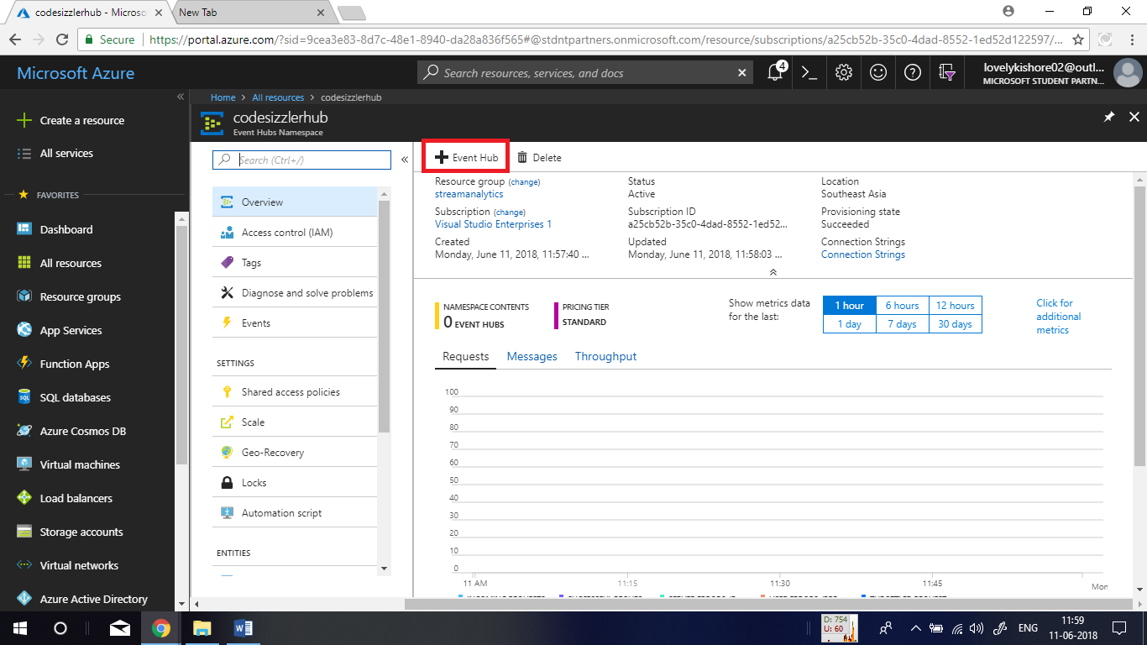

Give a name to the hub and click on **Create**.

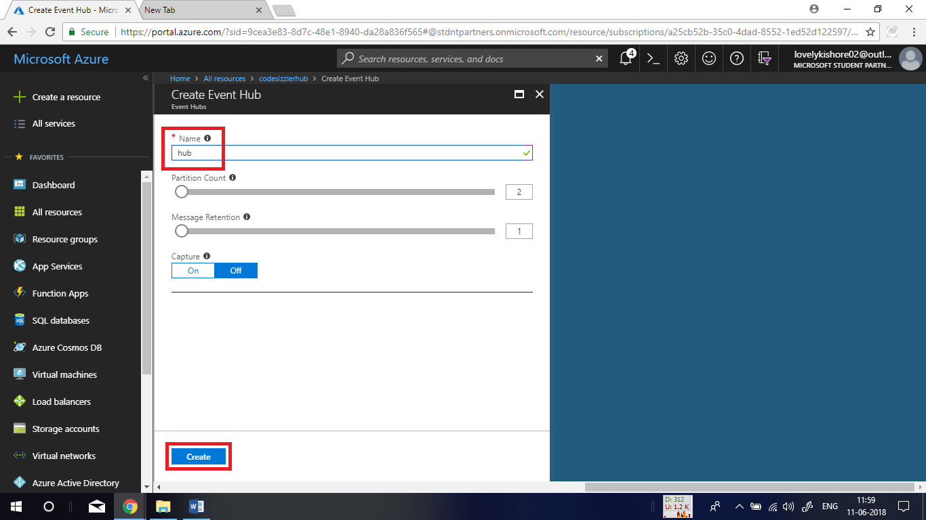

After completing this, go to the **Shared Access Policies** **-> RootManagerSharedAccessKey** and copy the connection string and maintain it in notepad for later.

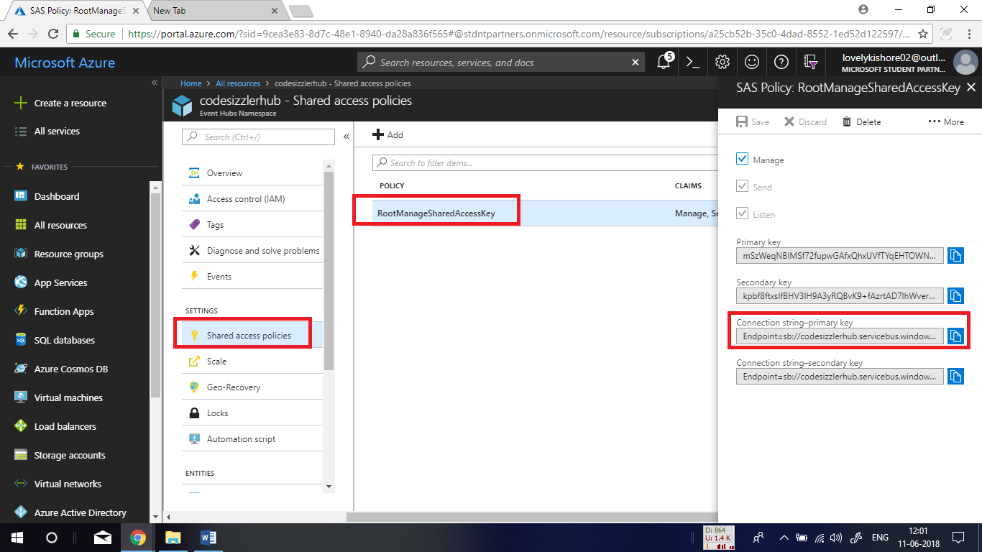

**Generating Phone Call Data:**

Extract the downloaded solution file in the beginning and open **telcodatagen.exe.config** file in notepad.

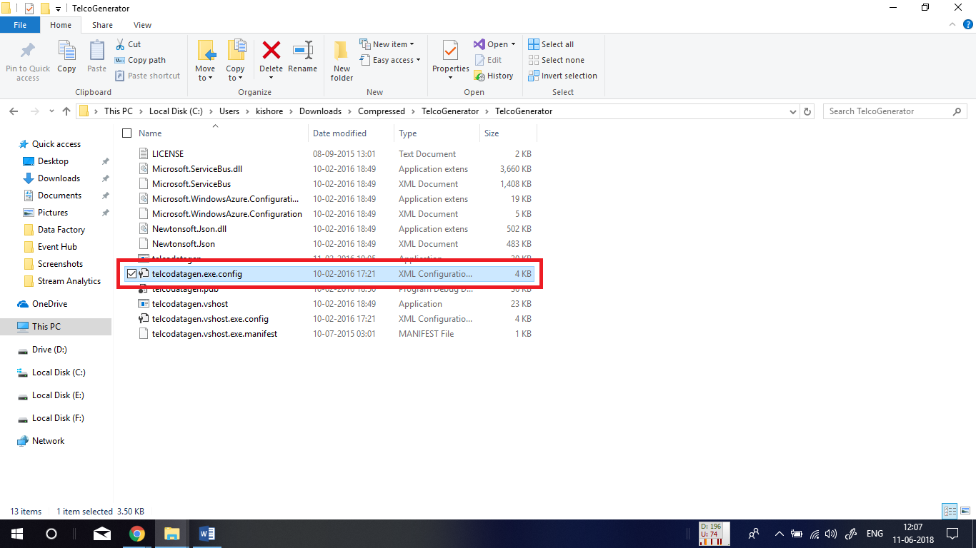

In the file that you opened, for **EventHubName** give the name of your event hub. Same way in the next line replace the **ConnectionString** with your connection string of your **EventHub**.

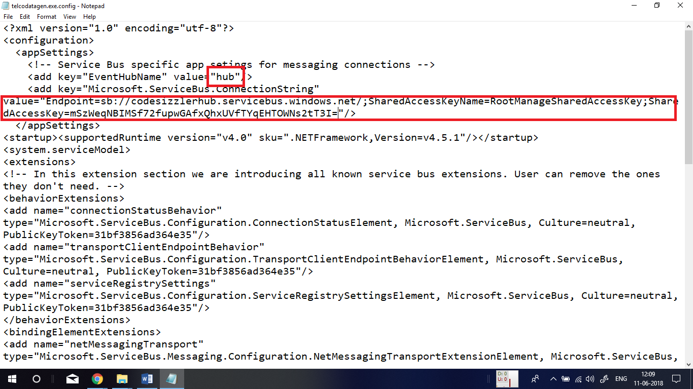

Now, open the command prompt and navigate to the folder in which you have solution files. After that execute the command

telcodatagen.exe 1000 .2 2

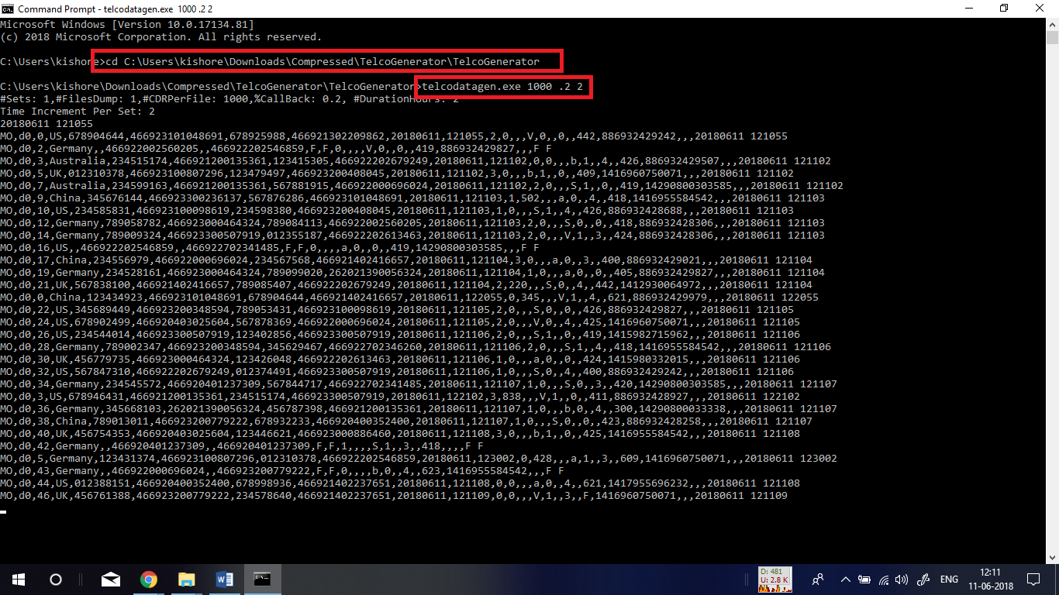

**Creating Stream Analytics Job:**

Go to **+ Create a resource -> Analytics -> Stream Analytics job**. Give the job a name, choose a resource group, a location and click on **Create** button.

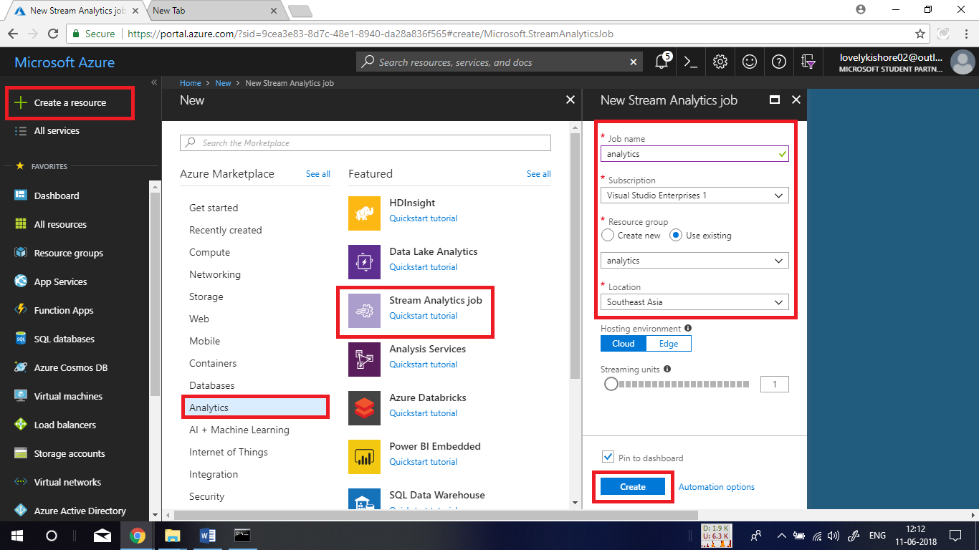

**Adding Inputs to Job:**

Once after the stream analytics job gets created, go to the **Inputs** and click on **+ Add stream input** and choose **Event Hub**.

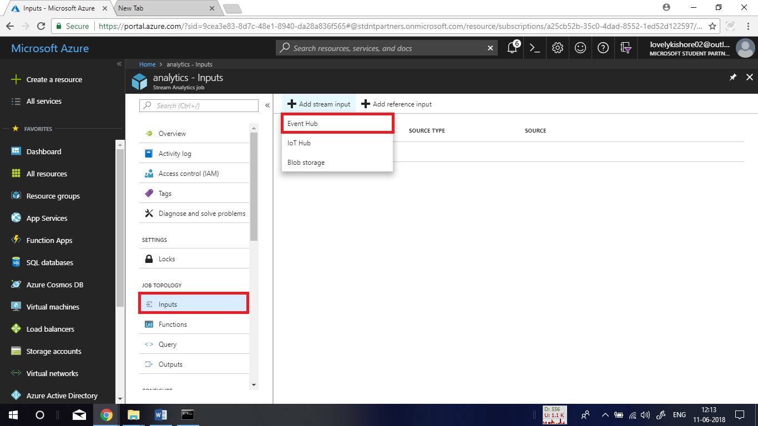

Now, give Input alias as **CallStream** and chose azure subscription. In the place of EventHub Namespace choose the EventHub that you created to receive phone call data. Choose the resource group and policy. At last click on **Save**.

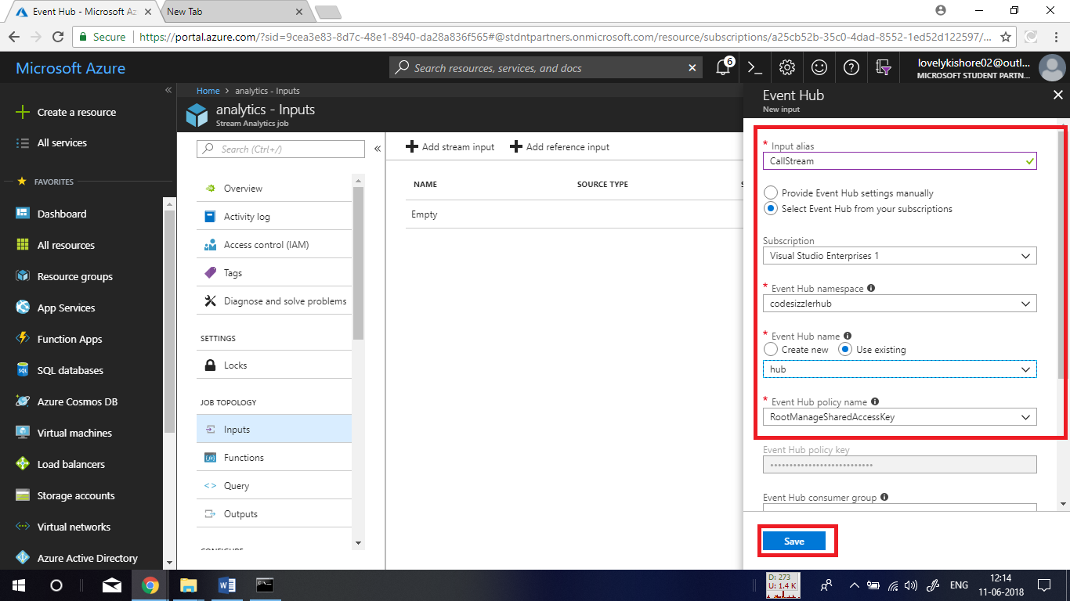

**Adding Output:**

Again, in the left side menu, click on **Outputs** and click on **+ Add** and choose **Power BI**.

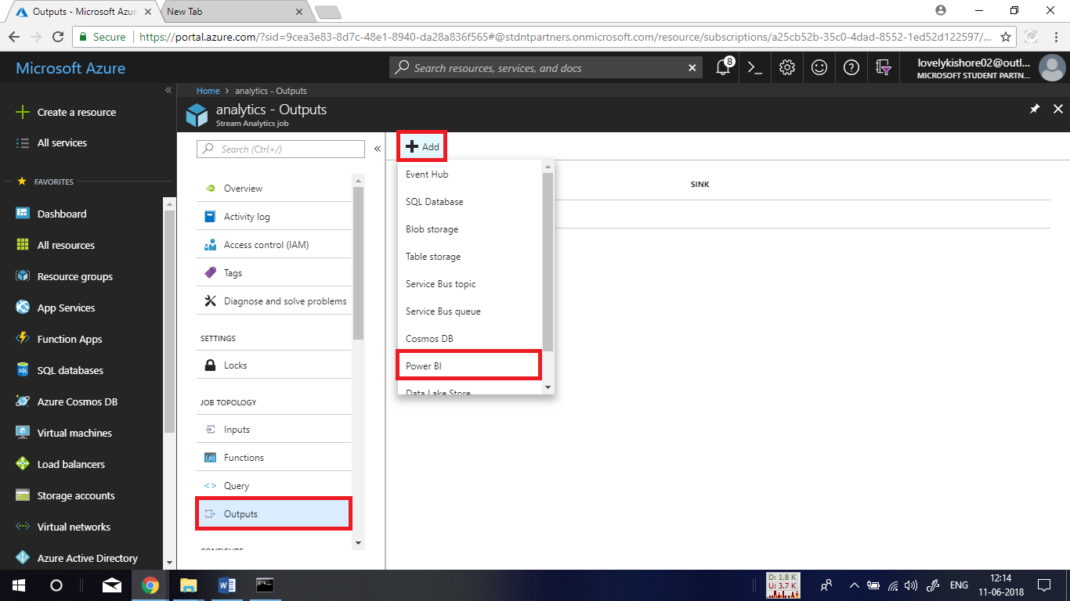

Next, name it as **MyPBIoutput** and choose group workspace as shown below. For **Dataset** **Name** give value as **ASAdataset** and table as **ASATable**. At last click on **Authorize** and click on **Save**.

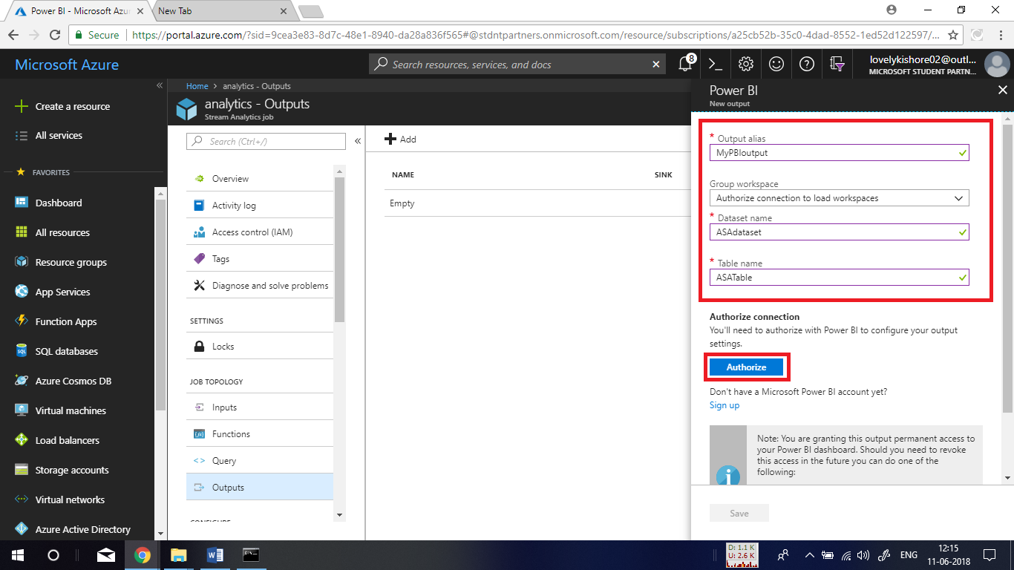

**Adding Query:**

Now, let us go to **Query** at the left side menu and add a piece of query finding fraudulent phone calls. Copy the below given query and paste it in the querying pane and click on **Save.**

**Query:**

SELECT System.Timestamp AS WindowEnd, COUNT(*) AS FraudulentCalls

INTO "MyPBIoutput"

FROM "CallStream" CS1 TIMESTAMP BY CallRecTime

JOIN "CallStream" CS2 TIMESTAMP BY CallRecTime

ON CS1.CallingIMSI = CS2.CallingIMSI

AND DATEDIFF(ss, CS1, CS2) BETWEEN 1 AND 5

WHERE CS1.SwitchNum != CS2.SwitchNum

GROUP BY TumblingWindow(Duration(second, 1))

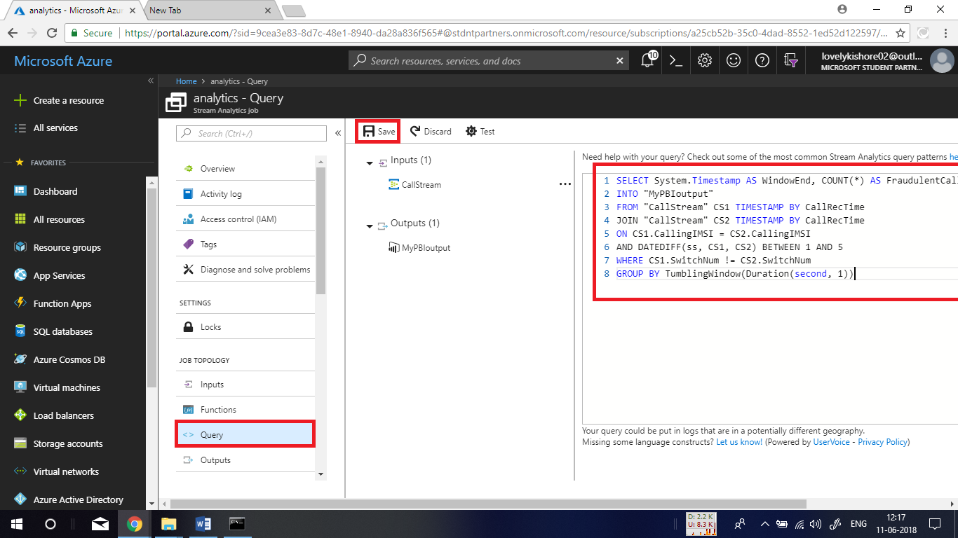

After saving the query, click on the dots as shown below and choose **Sample data from input**.

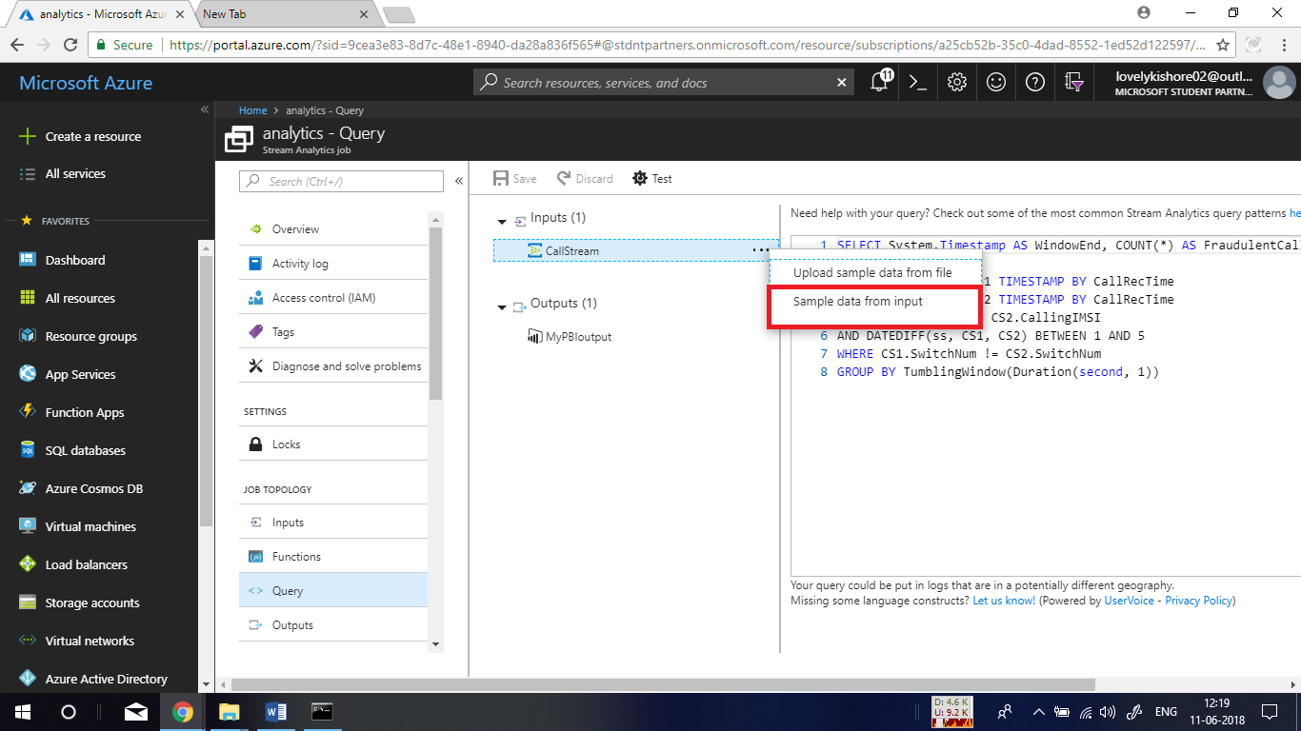

Let the Duration be 3 minutes and click on **ok.**

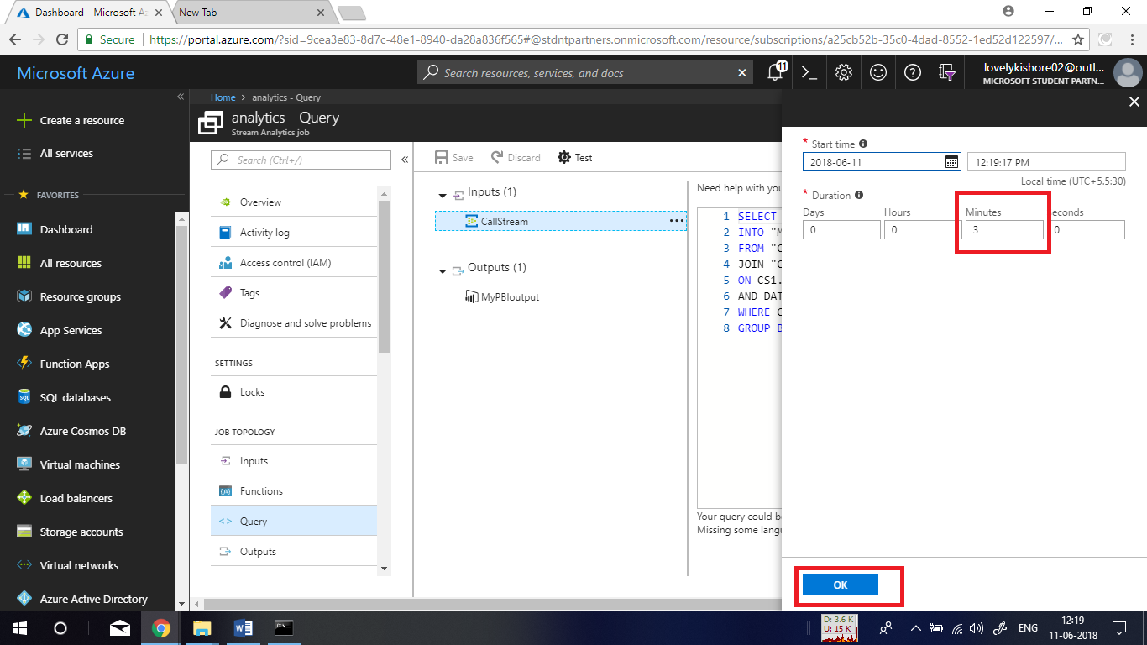

Now click on **Test**. This will query for Fraud calls that get registered by the application.

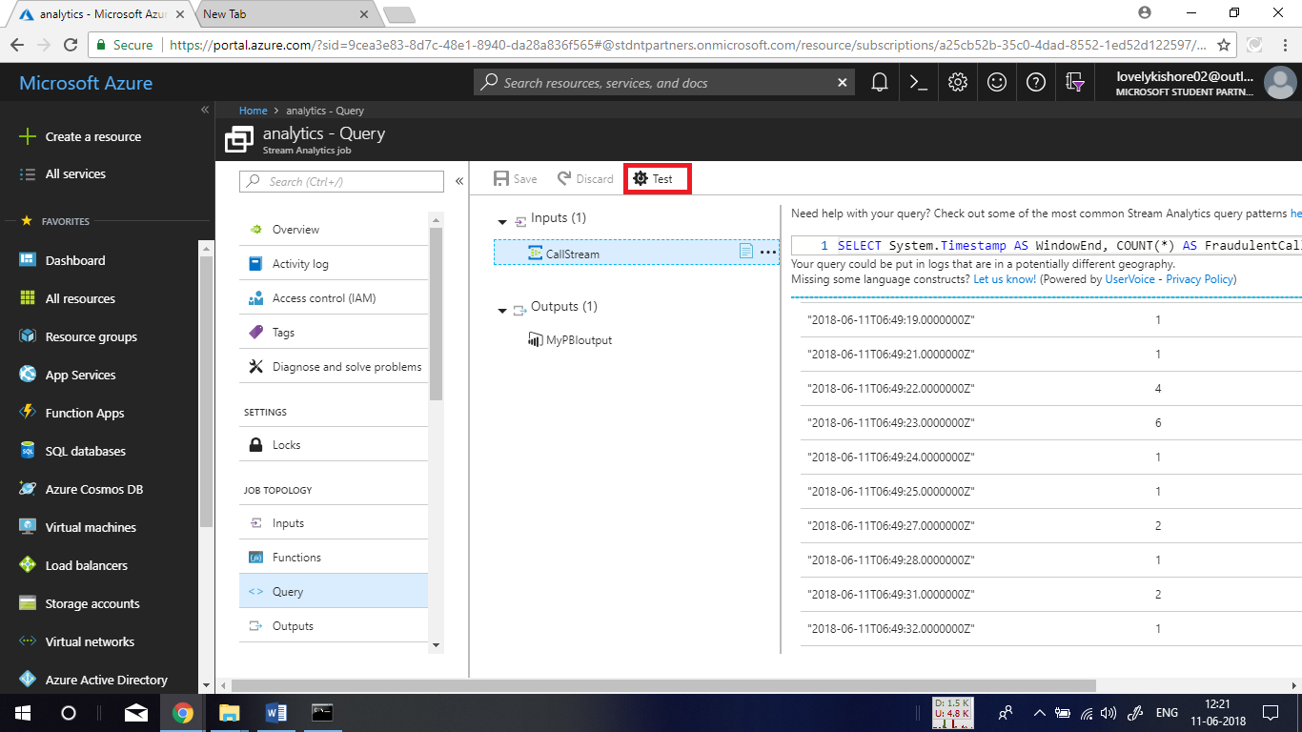

At last, go to **Overview** page of the job and click on **Start** buttonto begin the execution of job to detect fraud calls that are given as messages by EventHub.

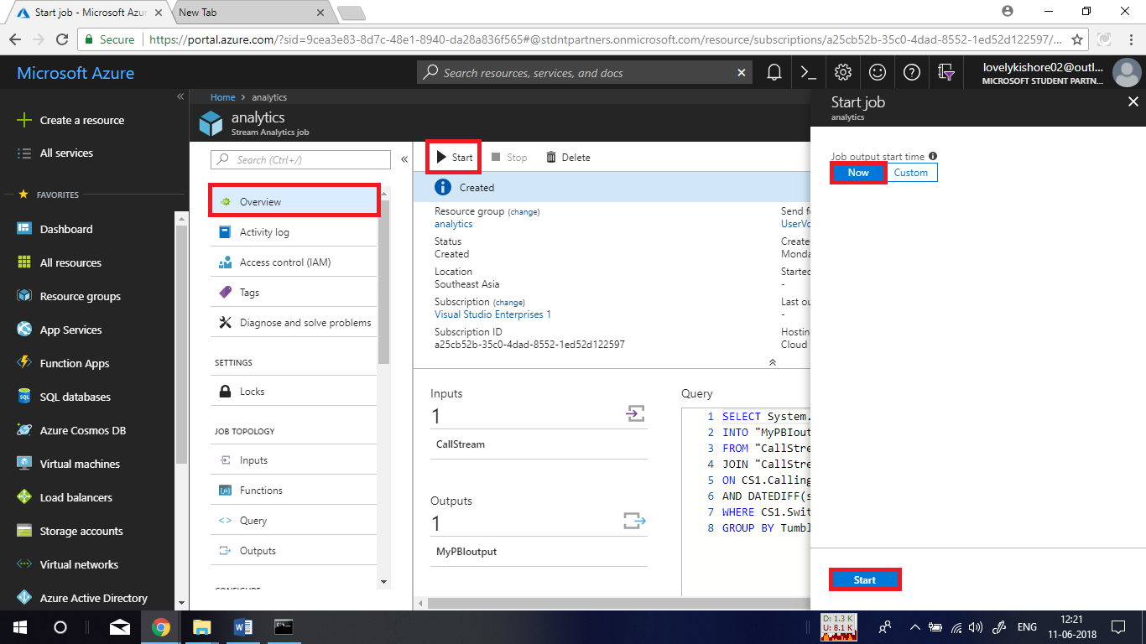

**Visualizing in Power Bi:**

Navigate to the site of Power BI from the link - <https://powerbi.com/> and login there using the same Power BI credentials that you used in stream analytics job. In the homepage of BI, click on **+ Create** and choose **Dashboard**.

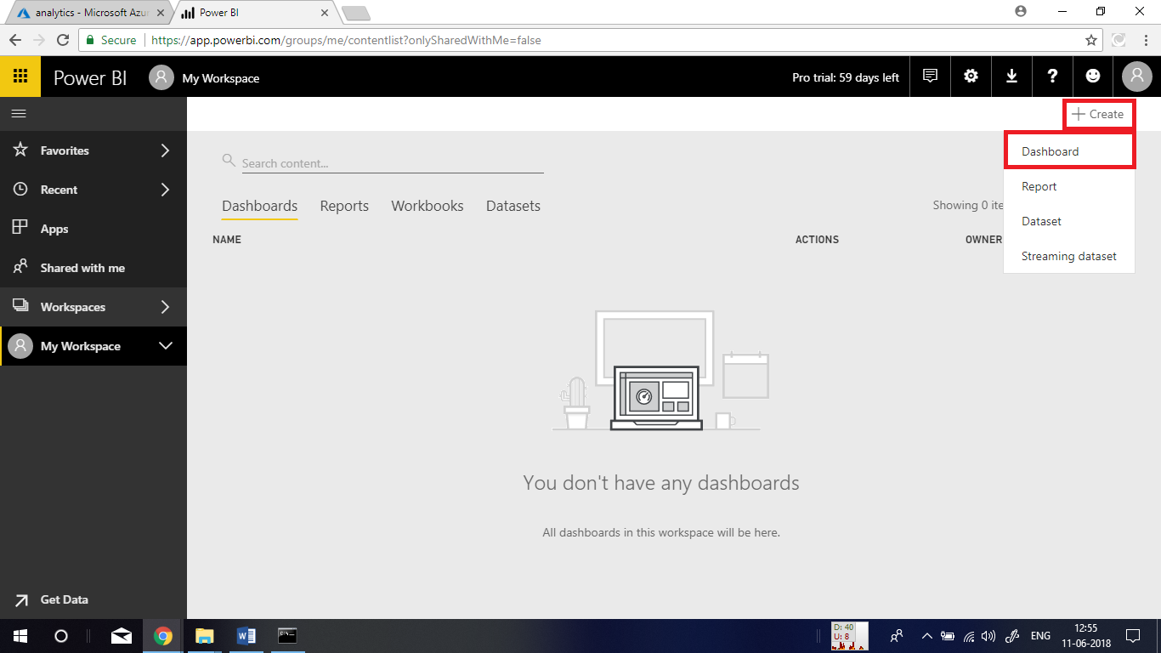

Name it as **Fraudulent Calls** and click on **create**.

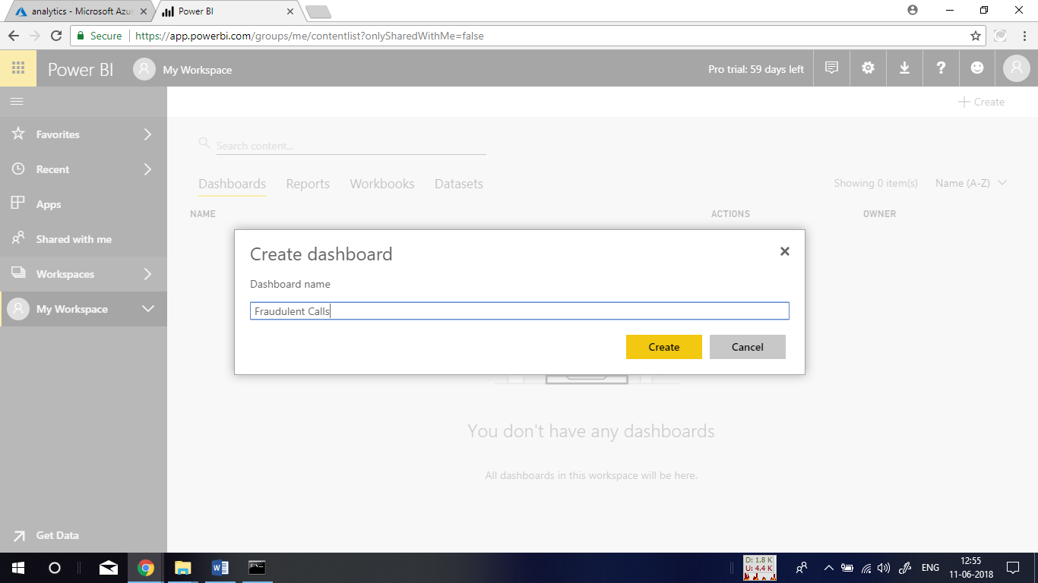

Now, click on **+ Add tile** and go to **Custom Streaming Data** and click on **Next**.

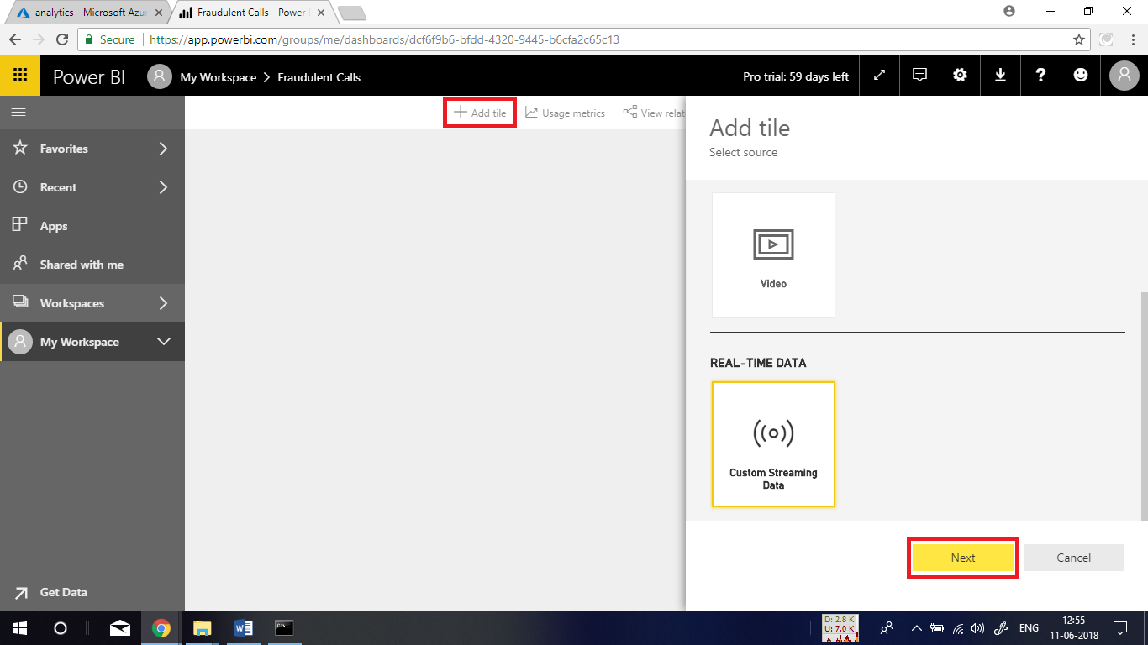

Next, in the place of dataset, **ASAdataset** and click on **Next**.

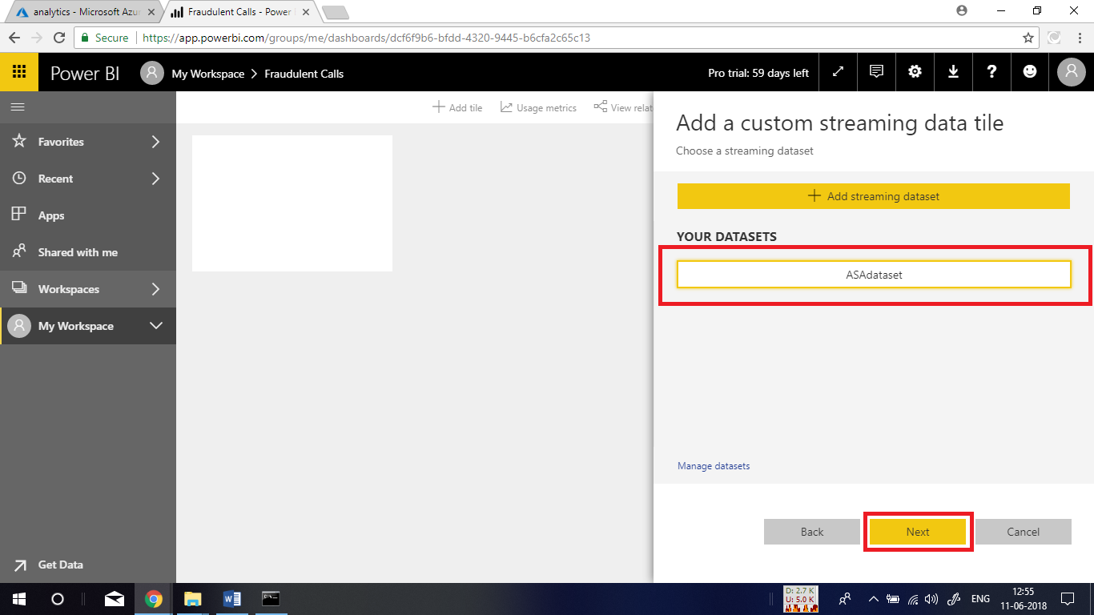

Now, for the visualization type choose **Card** and in **Fields** choose **fraudulentcalls** and click on **Next.**

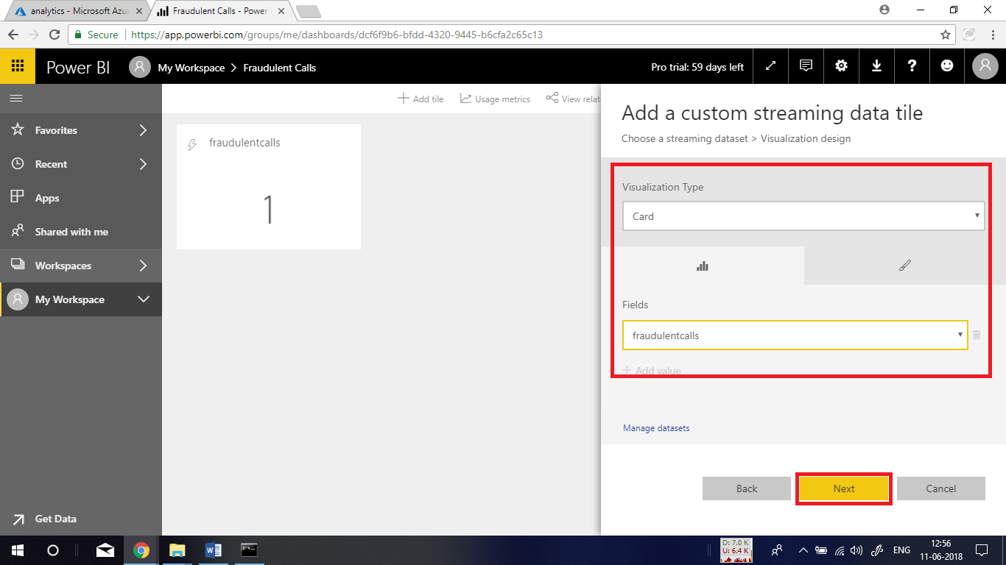

At last, name the tile and click on **apply**.

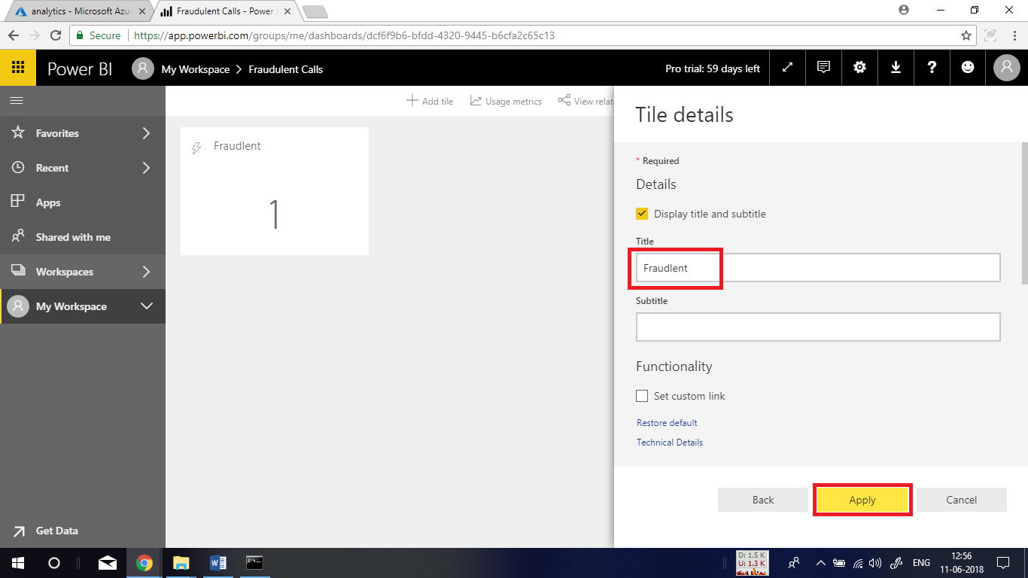

Once again click on **+ Add tile** and choose **Custom Streaming Data** and click **Next.**

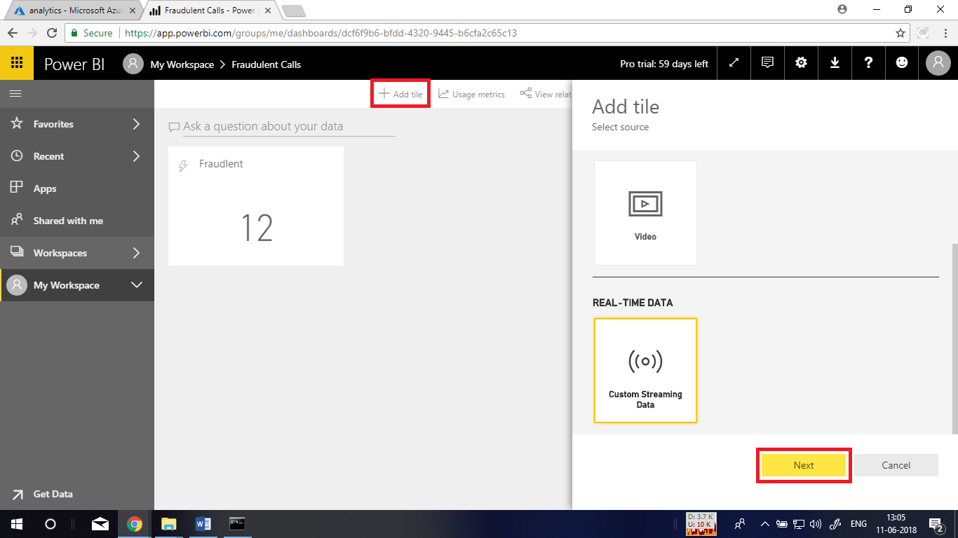

Choose the ASAdataset and hit **Next.**

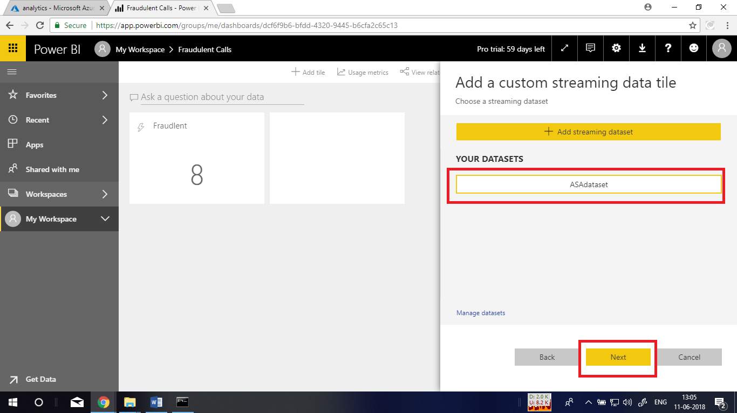

In the next window for Axis choose **windowend**. Same way for **Values** choose **fraudulentcalls.** Then choose 10 minutes for time window display and click **Next**.

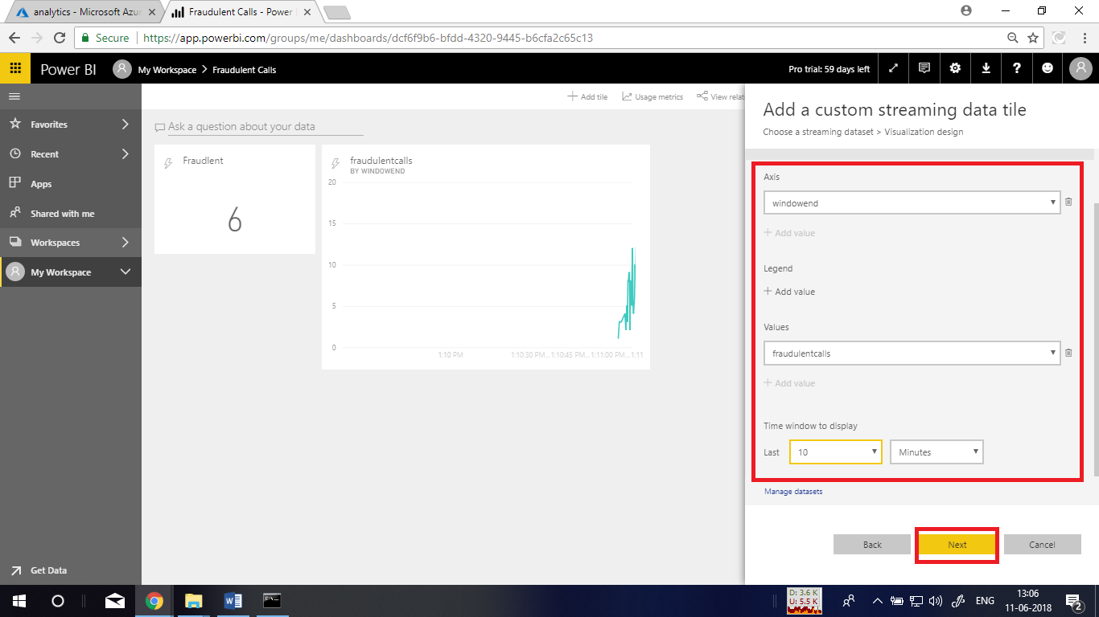

At last give it a name and click on **Apply**.

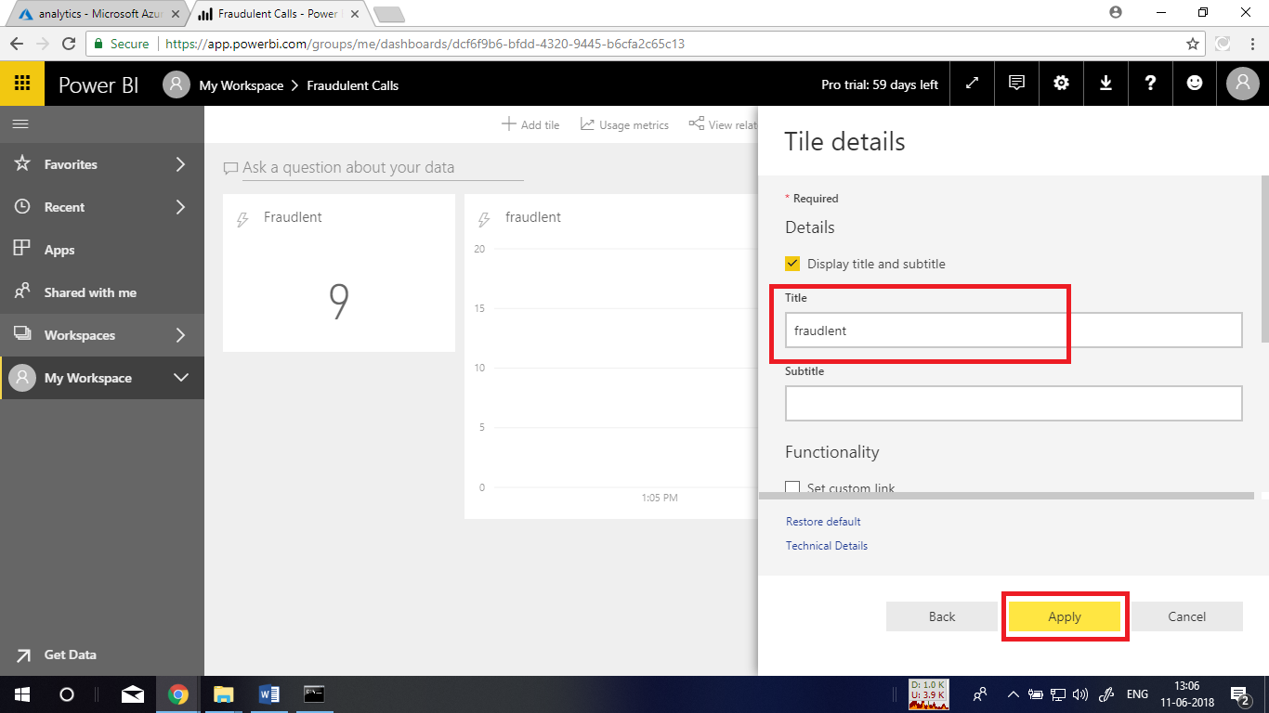

Now, you will be displayed with a windowed graph for the fraudulent calls that are generated by the application. Here, you will get the graph only when the data is sent by mobile client application to EventHub and analysed in stream analytics.

